DURATION: 2 Hours

THEORIC CONTENTS

* Lesson 3. Data Types.
* Lesson 4. Operators and Expressions.

GITHUB CLASSROOM ASSIGNMENT

**https://classroom.github.com/a/MXtKWHb2**

PROPOSED EXERCISES

Exercise 1. Design and implement a C program that request to the user his Name, age and weight, and it shows all data on screen.

Example of Execution:

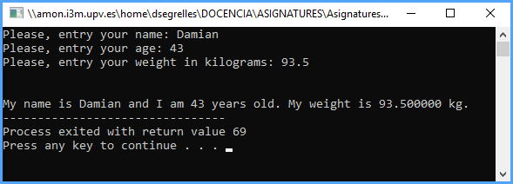

Exercise 2. Design and implement a C program that read this information:

* + Your Name (Ex. “Damian”)
  + First Surname (Ex. “Segrelles”)
  + Second Surname (Ex. “Quilis”)
  + NIF (ex. “48285791M”)
  + Birthdate (ex. “01/12/2009”)
  + Sex (F/M). (ex. F).

Finally, the program will show all introduced information on screen.

Example of execution:

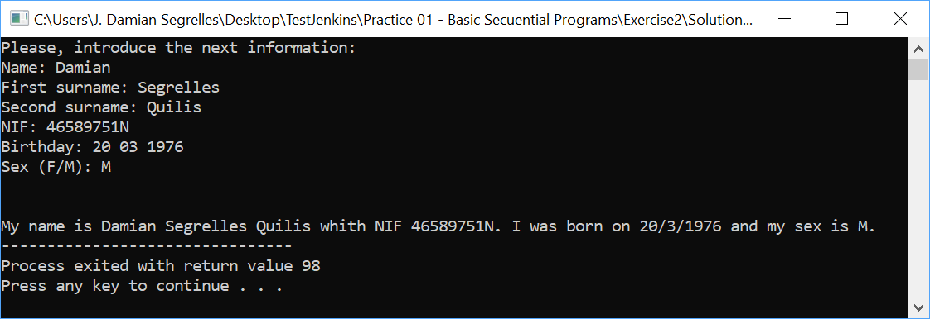

Exercise 3. Design and implement a C program that compute the area and perimeter of a circle.

Note: PI number should be considered as the fixed value 3.14159

Example of Execution:

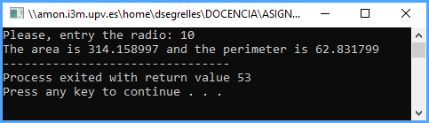

Exercise 4. Design and implement a C program that solves the next problem definition:

A car parts company needs a program that computes and displays the selling price (Euros) of its products. In this sense, the program should apply the following formula:

$$profit=cost_price*\frac{profit_margin}{100}$$

$$selling_price=cost_price+profit$$

The cost price and the profit margin are specified by the user. The program should read such values from keyword and then, it should compute the selling price. The result should be displayed on the screen.

Example of execution:

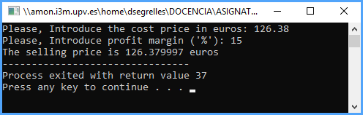

Exercise 5. Design and implement a C program that solves the next problem definition:

In the ETSID, every year are brought agendas for its students. The provider sells boxes of different size or single agendas. The size of the boxes is the follow:

* Big box with 50 units.
* Medium box with 20 units.
* Small box with 5 units.
* Individual units.

When bigger is the box, this is cheaper.

The program has to request to the user the number of agendas that the ETSID wants to buy and compute number of boxes (big, medium, small) and individual agendas that supposes for the ETSID the minimum cost.

NOTE: The size of the boxes should be considered as a fixed value.

Example of execution:

